**MAJOR PROJECT REPORT**

**on**

**WEATHER FORECASTING**

**Submitted as partial fulfillment of**

**MASTER OF COMPUTER APPLICATION**

**DEGREE**

**SESSION 2024-25**

**By**

**ANKIT JAYASAWAL**

**2300320140022**

**Under the guidance of**

**MS. NEELAM YADAV**

**(ASSISTANT PROFESSOR (Sr. SCALE))**

**ABES ENGINEERING COLLEGE, GHAZIABAD (032)**

  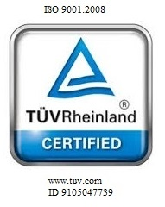

**AFFILIATED TO**

**Dr. A.P.J ABDUL KALAM TECHNICAL UNIVERSITY, UTTAR PRADESH LUCKNOW**